TI 22 – 13 Technology Example - Tooltec Caisson Crawlers/Inspection tools
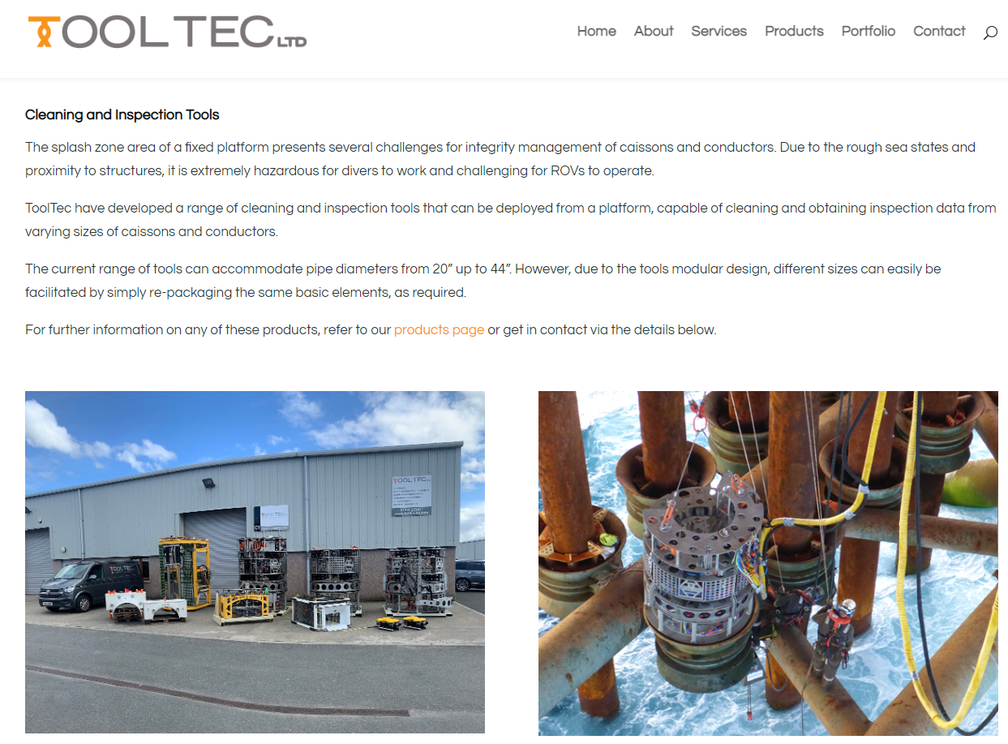

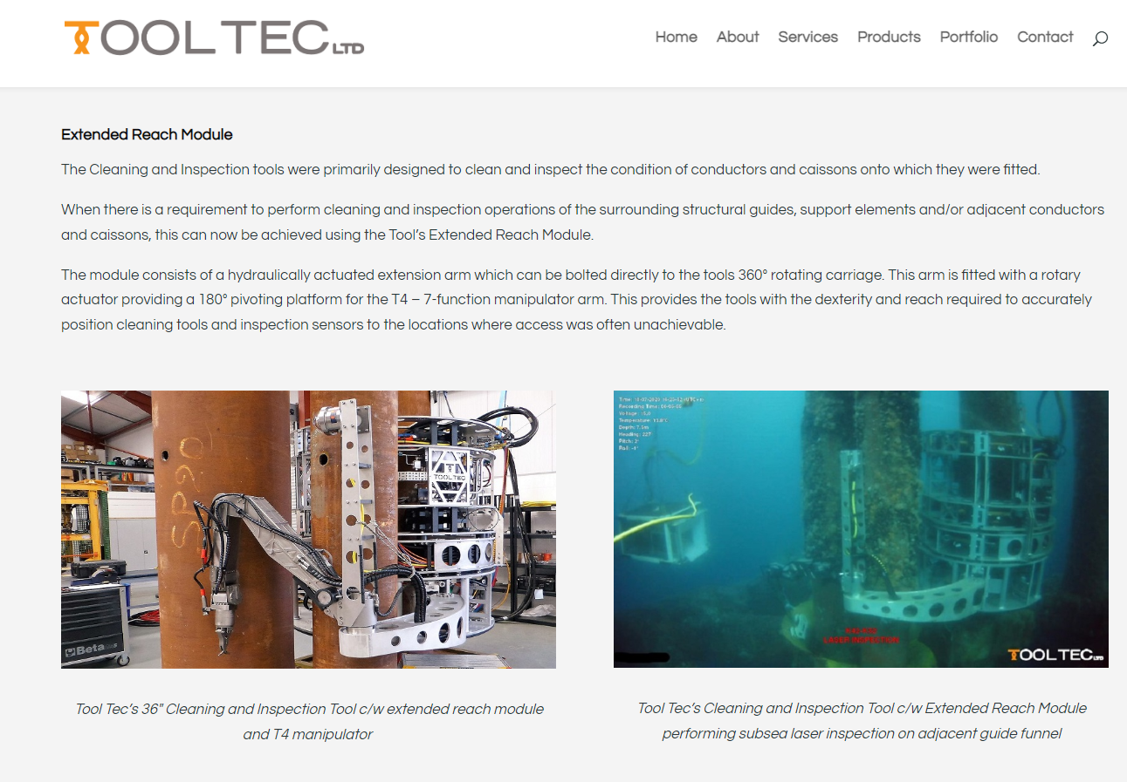
Link to vendors website for further information
Products - Tool Tec (tooltecltd.com)

